# Engaging with policy makers at national and European level

# Advocacy Toolkit for Rare Disease Patient Advocates

This toolkit is designed to help rare disease advocates effectively engage with policymakers at both the European and national levels, ensuring that the voices and needs of people living with rare diseases are heard and addressed in policy discussions.

It includes strategies, resources, and practical steps needed to advocate for policies that improve access to healthcare, treatments, and support for individuals with rare diseases and their family members. It is structured to help advocates understand the advocacy process, build relationships with key policymakers, and develop impactful advocacy campaigns.

**Advocacy, what for?**

* Advocacy aims to ensure everyone in society can have their voices heard, defend their rights and have their opinions heard and considered in decision making processes about their lives.
* Individual advocacy focuses on changing an individual’s situation and protecting their rights, while systems advocacy works to change policy and practice for groups of individuals who share similar problems. Both are vital for change to happen.
* Key elements of advocacy include the audience, context, information/evidence/data, your key messages, personal stories, humour, visuals and communication channels.

**Advocacy principles in these toolkit:**

* Know your stuff (situation of people with RD, political process);
* Know your people – make friends before you need them.
* Get into action – focusing on solutions.

**Contents:**

Engaging with policy makers at national and European level 1

Advocacy Toolkit for Rare Disease Patient Advocates 1

1. **Know Your Stuff: Understanding Your Advocacy Focus** 4

What is advocacy? 4

Advocacy Cycle 4

Key Advocacy Issues for the Rare Disease Community 7

Building Your Advocacy Position 7

Storytelling for advocacy 8

Developing key messages Exercise: 9

2. **Engaging with Policymakers: the four “Ps”** 11

Politics 11

Policy 11

Process 11

People 11

3. **Know Your People: Stakeholder Mapping and Engagement** 11

Stakeholder Mapping 11

Smart Choice: Targeting Key Policymakers and Stakeholders 12

Stakeholder mapping Exercise: 12

4. **Jump into Action** 12

Key Components of Your Narrative: 12

Preparing for Meetings with Policymakers: 13

Role-Playing Exercise: 14

1. **Tools for Success** 14

10 golden rules for written communication 14

Leave behinds: 14

Tools for Action: 14

Templates & Resources: 15

2. **Leveraging Media & Social Media** 15

Media Engagement: 15

Social Media Strategy: 15

3. **Evaluation and Continuous Improvement** 17

Impact Assessment Tools: 17

### **Know Your Stuff: Understanding Your Advocacy Focus**

#### **What is advocacy?**

* **First things first…** Advocacy is a planned, deliberate, and sustained effort to advance an agenda for change, ensuring that everyone in society has their voice heard, is listened to, and has their opinions considered in decision-making processes.
* In the context of health policy, being influential means having the ability to drive change, improve community health, and shape policy and stakeholder relationships. Influential public health leaders and organisations are viewed as credible and capable of affecting policies, legislation, and administrative actions, ultimately bringing about institutional change.
* While organising events may not always be the most effective strategy, engaging in meaningful, sustained actions—such as defending rights and participating in legislative advocacy—is essential. Although there is no universally accepted definition for a patient organisation, the European Medicines Agency defines them as not-for-profit, patient-focused organisations in which patients or their carers make up the majority of the governing bodies.
* Developing influence takes time, but it is a worthwhile investment for creating lasting change in health policy.

#### **Advocacy Cycle**

1. **Analyse Problems:** Advocacy begins by identifying and analysing the problems you want to address. Consider these questions: What creates value for the rare disease community that you represent? What rights are you trying to guarantee? And what could destroy value that is already there and jeopardise rights they already have? Once you’ve delved into a problem’s causes and effects, determine the priorities within that issue and what opportunities exist for change. This will help you determine what is achievable.
2. **Prioritise!** There are many problems to solve, but you have limited capacity to try to address them all at the same time. Therefore, it is important to prioritise which ones you will address first.

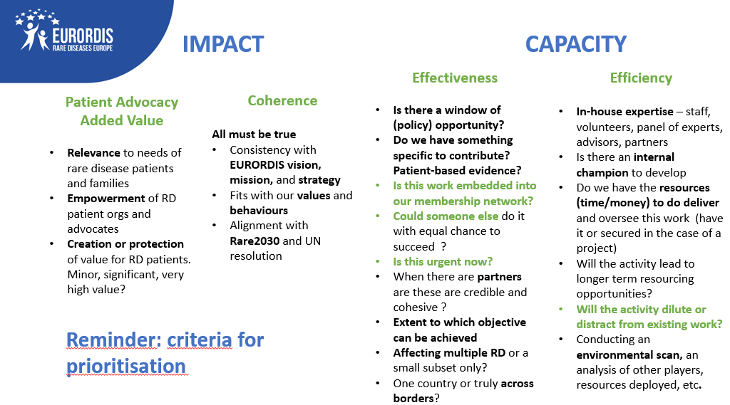

1. **Research Issue**s: Once the key issue has been identified, creating a research and data collection plan will enhance your ability to make a more persuasive case. This includes gathering relevant evidence from the rare disease community you represent, trying to reach as many people and families as possible, with diverse social and economic backgrounds.
2. **Identify your advocacy objective:** what are your the goals? What do you want to change? You will need these to consider the alliances you need to establish and your plan of action.

Campaign on the patients’ voting rights: the objective to block the majority position in Council on Articles xxx concerning patients’ voting rights removal in EMA committees before it goes to Trilogue, hence asking to keep the EC proposal. A plan derived from that involved considering the timing (vote in Council Working Party few days after; identifying decision makers (Member States, specifically MoH/Med agencies + health attaches); developing the message and recommendations(asks): keep the EC proposal wordings in Articles xxx of the Regulation; create the coalition EPF + National Alliances etc.

1. **Build Coalitions**: Mobilising support for your cause is a key component of advocacy. Increasing the number of people who support your goal will make your efforts more powerful. One way to do this is by building and strengthening platforms for advocacy with likeminded stakeholders; for example, building a coalition or a network with others interested in promoting a security sector that is more responsive to and inclusive of women.
2. **Plan for Action:** Create an action plan and choose tactics to influence the legislation, policy, or institutional practice you seek to change. Make sure to study and understand your legislative procedure and the mechanisms of decision making associated to the problem you are trying to solve.
3. **Develop Recommendations:** Formulate concrete recommendations for action, directed to specific security sector institutions. When crafting advocacy recommendations, you must be as specific as possible in identifying what needs to happen, who can make that happen, and how the actor identified can make that happen.
4. **Deliver Your Messages**: Once you decide who your target audiences are (e.g., politicians, civil servants, senior people in the security sector, the media), create and deliver strategic messages that will resonate with them. This often requires creating more than one message for more than one audience, but this step is crucial in attracting attention and gaining public support for your issue.
5. **Monitor and Evaluate Progress:** Advocacy is an ongoing process of learning and reflection. What does success look like? How can you improve your advocacy efforts along the way? Evaluating advocacy can help track progress towards your goal and allow you to adjust your actions as needed.

Adapted from: <https://www.dcaf.ch/sites/default/files/imce/Women's%20Guide%20Curriculum/InclusiveSecurity_Curriculum_Series_SSR_MOD10.pdf>

**Measure your resources as patient’s organisations**

* Patientorganisations often face challenges in being formally recognised as credible stakeholders in both health and non-health policy debates. Their input is sometimes dismissed as biased or too narrowly focused.
* Additionally,with declining public health and researchfunding,many are driven to seek private financial support. Despite these challenges, awareness of the importance of transparency and ethical conduct has grown, and patient organisations have become increasingly professional over time.

#### **Key Advocacy Issues for the Rare Disease Community**

** Key issues for people living with rare diseases and their families (non-exhaustive):**

* **Access to Treatment & Healthcare:** Highlight barriers to treatment availability and the need for equitable healthcare systems.
* **Orphan Drug Legislation:** Advocating for policies that incentivise the development of rare disease treatments.
* **Person-Centred Care:** Ensuring that people with rare diseases have access to holistic, person-centred, multidisciplinary and continuous care.
* **Early Diagnosis:** Advocating for policies that improve early detection and diagnosis of rare diseases.
* **Research and Innovation Funding:** Ensuring adequate funding and support for rare disease research.
* **Rights and Social Participation:** Advocating for the rights of people with rare diseases to enjoy their best health, including mental health, and to participate in society on an equal basis with others, including independent living rights, employment, and education.

**But you should identify the key issues for your community. Think about the following question:**

* “What is advocacy to you? And why are we discussing it today?”
* It starts with why!

#### **Building Your Advocacy Position**

* **Key Messages**

Your key messages should identify the main issues faced by your community and should be communicated in a concise, understandable and impactful way – this implies adapting your messages depending on your audience! But in general, should convey urgency and a “human”, anecdotal element.

See more info here > <https://www.dcaf.ch/sites/default/files/imce/Women's%20Guide%20Curriculum/InclusiveSecurity_Curriculum_Series_SSR_MOD15.pdf>

* **Supporting Facts and Evidence**

Sources for research that support your position can be found via:

* + EURORDIS Rare Barometer surveys: https://www.eurordis.org/publications/make-your-voice-heard-rare-barometer-guide/
  + Academic research (Google Scholar, etc)
  + Your own research: Open Academy Course > <https://openacademy.eurordis.org/courses/survey-design-rare-disease-patient-organisations/>
  + Publications in your specific disease area

#### **Storytelling for advocacy**

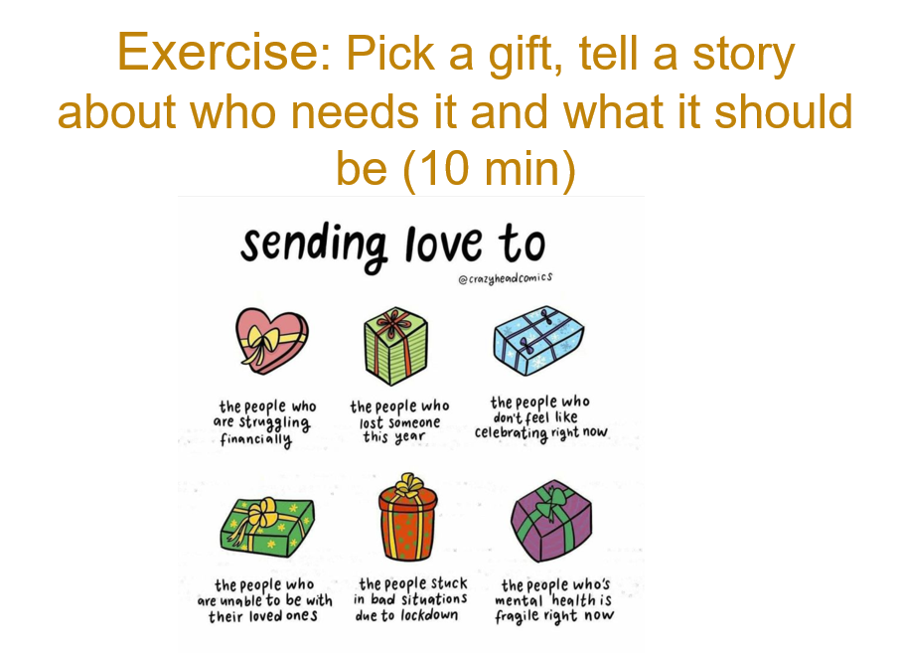

**Planning to engage with a policy maker?**

* What do you want other people to understand about your experience and that of rare diseases?
* What might they now know?
* Tell a story that connects the audience with your experience
* Create a link between your story and the policy ask

**Why story telling?**

* Stories work because they are a simple, accessible way of explaining an issue and potential solutions - they show what helps make change possible and tell the audience how they can help ensure a good outcome.
* Stories from people with rare diseases are particularly powerful because they show the real experiences behind the statistics, and help people understand and empathise with the challenges individuals, carers and families face.
* Stories need to be compelling and show opportunities for change. You need to find a theme that your audience identifies with. Important parts of the story include where it happens, who is involved, and the situation taking place. You should also think about the background of the situation and take note of any conflict, drama, opposing forces, choices, actions and solutions. Highlight interactions between characters and keep it concrete. Ask yourself what is interesting and powerful about the story.
* Repeating facts is not enough to convince people or make them change their minds - they have to be accompanied by persuasive stories and anecdotes. On functional MRI scans, many different areas of the brain light up when someone is listening to a narrative. Networks involved in language processing, but other neural circuits, too. One study of listeners found that the brain networks that process emotions arising from sounds — along with areas involved in movement — were activated, especially during the emotional parts of the story.
* Decision makers are inundated with data, and they’re much more likely to remember a story than a graph on a slide. Stories make the presenter more likable. Being likable and building rapport are key elements – sometimes requirements - for influencing others.
* Stories create an almost instant opportunity for authentic connection.
* Stories are more memorable than statistics, and make the person telling them seem more likeable. They open a door to authentic connection between the storyteller and decision-maker.
* You make your ideas stick in people’s minds by keeping them simple, unexpected, concrete, credible, emotional and using stories to explain them.

#### **Exercise: Developing Key Messages:**

* **Objective:** Practice developing impactful advocacy messages.

### **Engaging with Policymakers: the four “Ps”**

#### **Politics**

**Be aware of what is happing around you…** For any association engaged in advocacy, understanding the political environment is not just useful—it's essential. The political landscape shapes the boundaries and opportunities for influence, and staying attuned to it allows advocacy groups to navigate effectively, strategically, and ethically.

**Analysis of power dynamics:**

* + Helps identify who holds influence and where decisions are made.
  + Reveals opportunities for building alliances or applying pressure.
  + Clarifies institutional and stakeholder relationships that affect your agenda.

**Monitoring geopolitical developments**

* + International events can shift policy priorities and public attention.
  + Political instability or global crises may either hinder or accelerate action.

**Current Political Climate**

* + Determines public and policymaker receptiveness to certain issues.
  + Polarization, elections, or shifts in leadership can rapidly change advocacy terrain.
  + Influences how messages are framed to gain traction across different audiences.

**Understanding the political context is key!**

* + Aligning with political or legislative calendars increases visibility and impact.
  + Awareness of competing priorities helps in positioning your issue effectively.
  + **It helps in identifying threats**: policy changes, funding cuts, or regulatory shifts may negatively impact your cause.
  + **It helps in identifying oopportunities**: new leadership, funding initiatives, or global attention can create momentum.

**“Forcefield analysis”**

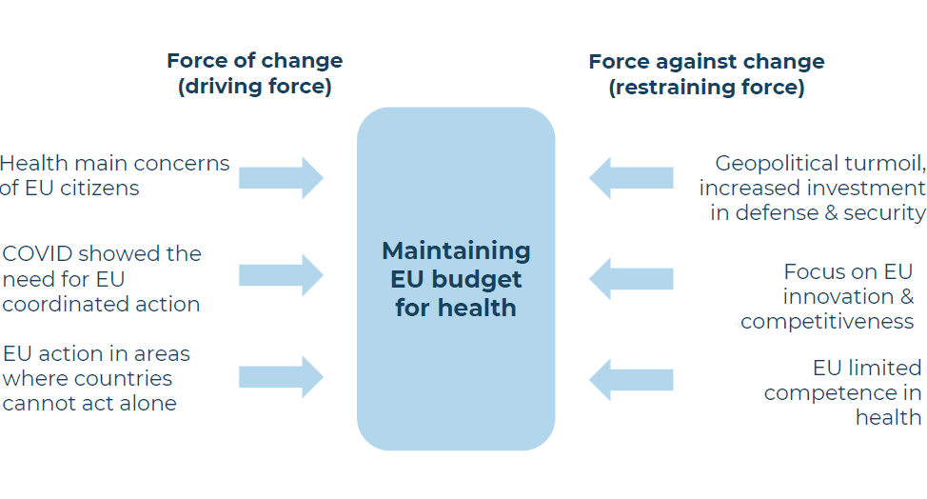

#### **Policy**

**Be aware of what the institutions are/are not/could be doing…**To effectively influence policy and represent your community, it’s essential to understand both the broader political environment and the specific content of laws, regulations, and strategies being developed. This means knowing not just what’s happening, but why it matters, how it affects your interests, and when to act.

**What’s being proposed?**

* + Track new laws, policies, and strategic plans in development.
  + Identify how these proposals align or conflict with your mission and objectives.

**What’s being debated?**

* + Stay engaged in public and legislative discussions on key issues.
  + Monitor how the conversation is evolving and who is shaping it.
  + Recognize when to intervene, provide input, or mobilize supporters.

**What’s being revised?**

* + Policy revisions can have just as much impact as new proposals.
  + Understand how changes to existing laws or strategies may affect your stakeholders.
  + Provide constructive feedback during consultations or public comment periods.
  + Position your association as a knowledgeable and reliable policy stakeholder.

**What could be done but is not?**

* + Think of what is not addressed by current political agendas and speak to policymakers
  + Identify what to ask to who

#### **Process**

**Be aware of the journey ahead…** Be ready to understand the formal and informal steps of the legislative process, line out a roadmap of what do and when!

**Map the Process**

* + Understand how decisions are made at each stage of the policy cycle.
  + Learn who holds influence at different points—and when to engage them.
  + Use this knowledge to plan your strategy, not just react to developments.
  + Recognize both official procedures and behind-the-scenes dynamics.

**Time Your Advocacy**

* + Know when critical windows for influence open—and when they close.
  + Engage early, especially during agenda setting and drafting stages.
  + Avoid wasting effort when positions are already locked in.

#### **People**

**Be aware of the people involved**… It is fundamental to know what to say to whom!

* + Policymakers at both the European and national levels
  + Map your stakeholders *(more in the next chapter)*
  + You can anticipate resistance or support based on what’s happening politically or socially
  + Strategic targeting is crucial — building relationships with the right people at the right time can amplify your impact



**Campaign on the patients’ voting rights**

**Objective**: block the majority position in Council concerning patients’ voting rights

removal in EMA committees before it goes to Trilogue, hence asking to keep the EC

proposal.

* **Solution: A plan derived from that involved:**

• forcefield analysis (see next slide)

• consider the process (revision of the EU pharma legislation, EU ordinary legislative

procedure)

• consider the timing (vote in Council Working Party few days after);

• identify decision makers (Member States, specifically MoH/Med agencies + health

attaches);

• create the coalition EPF + National Alliances etc.

• develop the message and recommendations (asks): keep the EC proposal wordings

in Articles xxx of the Regulation;

### **Know Your People: Stakeholder Mapping and Engagement**

#### **Stakeholder Mapping**

It’s important to understand the external context to your advocacy, not just internal factors (like consensus amongst memberships, financial and human capacity and resources etc.) because advocacy hinges on influencing actors outside your organisation to take action.

* **Who Are the Key Policymakers?** **Who are the actual decision makers?**
  + **European Level:** Members of the European Parliament (MEPs), European Commission (DG Health), Council of the EU, European Medicines Agency (EMA), European Health Insurance Plans (EHIC). Are all MEPs and European Commission representatives equally important? How can you identity the actual decision makers? E.g. MEPs who are rapporteurs on a file have more influence.
  + **National Level:** Health and Welfare ministers, members of national parliaments, patient associations, national health agencies, and regulatory bodies.
  + Understanding how the EU works: Open Academy courses > <https://openacademy.eurordis.org/courses/european-union-institutions/> &

<https://openacademy.eurordis.org/courses/ordinary-legislative-procedure/>

* **Who Are Your Allies?**
  + Rare disease patient organisations and advocacy groups (e.g., EURORDIS, national alliances, European federations, other patient organisations).
  + Medical professionals, researchers, and scientists in rare disease fields.
  + Pharmaceutical companies working on orphan drugs and treatments?
  + Social workers, mental health support workers, community services.
* **Who Are Your Opponents or Challenges?**
  + Budgetary constraints, competing healthcare priorities.
  + Potential opposition from groups that do not see your position as a priority.

#### **Smart Choice: Targeting Key Policymakers and Stakeholders**

* Identify the individual policymakers who have the most influence over issues that affect your community i.e. healthcare funding, orphan drug regulation, rare disease research etc.
* Consider their stance and their history with rare disease advocacy.
* Tailor your messaging to align with their interests, demonstrate the impact of rare diseases on their constituency or Europe at large.

**A policy maker:**

* Has spent time building social and political capital. Safeguards public image and reputation.
* Operates in a political hierarchy.
* Personal story and interests.
* Short on time, limited attention for details.
* Constantly assesses trade-offs: media appeal, popular support, feasibility, cost.
* Interest may depend on election cycle.

**Remember! Timing is of the essence!**

* The earlier in the process you meet with your stakeholder, the easier it will be to achieve your desired impact.

 If you meet with the European Commission while they are preparing a proposal, it will be much easier to get your points in that if you meet with policy makers once the proposal is approved within the EC and being discussed in the so-called Trialogues with the other EU institutions.

#### **Exercise: Stakeholder mapping**

* **Objective:** Practice mapping relevant stakeholders.
  + Stakeholder mapping and how to us it > <https://www.intrac.org/app/uploads/2022/06/BA-Advocacy-Toolkit.pdf>
  + <https://www.intrac.org/app/uploads/2022/06/Advocacy-Tool-Power-and-stakeholder-analysis-mapping.pdf>

### 

#### **Exercise: Building your Advocacy Message: Problem, Solution, Action**

**Remember!**

* 4 Ps: Politics, Policy, Process, People.
* Spend 20& of the time on the problem and 80% of the time on the solution.
* Be clear and concise.
* Make it targeted to your audience.
* Include ‘human’ elements.

1. **Goal and Objectives:**

What long-term change are you trying to achieve through your advocacy (your goal)?  
What specific, measurable outcomes or actions will help you get there (your objectives)?  
How do these objectives support or lead to the goal?

**Goal:**

**Objectives:**

1. **Audience:**

Who is your stakeholder? Are they a decision maker or an ally? Are your objectives realistic for your audience to act on? Can they clearly see their role in achieving them? What are their interests? Think of how you will tailor your message to their interests and to demonstrate the impact on their constituency. What may they already know? Consider their stance and their history with rare disease advocacy.

1. **Problem:**

What is the main issue you are trying to address? What evidence do you have to support your position? How can you use personal stories to humanise the way in which you present your problem and demonstrate the urgency of action?

1. **Solution:**



Outline 2-3 specific actions your audience can take. This is where you describe how your audience can help you reach your objectives. Give specific, targeted asks - what can this specific audience do to help address your problem.

### **Jump into Action**

#### **Key Components of Your Narrative:**

* Personal stories that humanise the issue and demonstrate the urgency of action.
* Data-driven evidence that supports your position (e.g., cost savings of early diagnosis, number of people affected, unmet medical needs).
* The importance of EU and national-level policy changes to improve lives.

#### **Preparing for Meetings with Policymakers:**

* **Before the Meeting:**
  + Research the policymaker’s background, their position on healthcare, and their previous work on rare diseases.
  + Develop a clear agenda for the meeting, outlining the key asks (e.g., increased funding for rare disease research, amendments to orphan drug laws).
  + Be concise and clear about your issue and why it should matter to them.
* **During the Meeting:**
  + Share your story and make it personal.
  + Provide supporting facts and data to back up your position.
  + Focus on the potential impact of policy changes on both patients and society.
  + Ask for specific actions (e.g., signing a petition, advocating for legislative changes, supporting a budget allocation).
* **After the Meeting:**
  + Send a follow-up email thanking them for their time, reiterating key points, and providing additional resources or evidence if necessary.
* Keep the lines of communication open for future advocacy opportunities.
* **Watch The Good, the Bad and the Ugly**
  + <https://youtu.be/XxqvbeqrR8s>
  + <https://youtu.be/vCfnOt_56ok>
  + <https://youtu.be/Hzk5fduCuKk>

**Oral communication/meetings:**

1. Introduce yourself.
2. Problem.
3. Your ask (solution).

**Remember!**

* Follow the W rules (Who, What, When, Where, Why)
* Be prepared, be on time, be yourself, be flexible.

**10 golden rules for oral communication:**

* Be yourself and don’t read out a pre-prepared text.
* Use body language, and turn physically towards your audience.
* Facilitate interaction with the audience.
* Adapt your vocabulary to the audience, particularly when you are being translated in real time (avoid acronyms and specific national sayings).
* Adapt your rhythm to the size of the room e.g. you should speak more slowly and simply to a larger room and audience.
* It’s better to speak for too short a time than too long a time.
* Address your subject straight away. Explain the subject of your speech, highlight each key idea, and signal when you are approaching the end of you presentation.
* Comply with the time limits given to you.
* Never avoid questions. If you don’t know the answer, offer to follow up by email.
* Limit your presentation to two or three key ideas.

#### **Role-Playing Exercise:**

* **Objective:** Practice a policymaker meeting.
  + One participant plays the policymaker; another plays the rare disease advocate.
  + Focus on clear communication, presenting your case, and asking for action.

### **Tools for Success**

#### **10 golden rules for written communication**

* Select the ideas you want to express.
* Decide what you want to do with your writing - convince/explain/propose?
* Ask yourself who will read your document (journalists/politicians/officials).
* Decide how long your text will be.
* Only start writing once you have done the above tasks.
* Use simple words and short sentences.
* Use a title, subtitle and short paragraphs.
* Have a short introduction and strong conclusion.
* Be positive: use a dynamic style with credible proposals.

Check translations very carefully and pay attention to the layout of your document.

#### **Leave behinds:**

* Position papers, summary documents, etc.

#### **Tools for Action:**

* Encourage supporters to sign petitions, attend meetings with policymakers, or participate in public events like Rare Disease Day.
* Create an event calendar with key advocacy moments (EU hearings, national health policy debates). Make sure to distinguish the ‘fluffier’ events (hearing, debates etc.) and procedural events (voting ) The latte define the advocacy calendar (e.g. deadline for amendments).

#### **Templates & Resources:**

* **Sample Letter to Policymakers:** A template for contacting European and national policymakers, asking them to support issues that matter for people with rare diseases.
  + Example: [Written templates](https://drive.google.com/drive/folders/1aAFQtlm3wi0BGVVICX3RJQ-WhYd3v79s) of Keep Patients Voting Campaign (2025).
  + Example: [Open letter](https://download2.eurordis.org/ecrd/2024/ECRD_2024_Open_Letter.pdf) #ActRare2024 (2024).
  + Example: [Letter to EU Health Commissioner](https://download2.eurordis.org/ecrd/Follow_up_letter_from_ECRD_2022.pdf) calling for a European Action Plan on rare diseases (2022).
* **Fact Sheets & Briefing Documents:** Provide concise documents that summarise key issues, statistics, and research for policymakers.
  + Example: “[Championing the rare](https://download2.eurordis.org/publications/Manifesto_short.pdf): Building the Engine of an Inclusive European Health Union”. Briefing of EURORDIS Campaign for the 2024 EU Elections (2024).
* **Examples of legal tools that can be used for Advocacy:** “[Legal toolkit for patient advocates](https://eduinstitute.org/application/files/5117/4834/4900/Legal_Toolkit_EDUinstitute.pdf): Report on the patients’ participation in decision-making and law-making processes” (2024, Healthcare Education Institute).

### **Leveraging Media & Social Media**

#### **Media Engagement:**

* **Press Releases:** Announce key moments in your advocacy campaign or breakthroughs in rare disease treatment, care and support.
* **Op-Eds & Letters to the Editor:** Write about the importance of rare disease policies and why they should be a priority.
* **Media Interviews:** Work with journalists to raise awareness of rare diseases and share the needs of the community. Strive to demonstrate the sense of urgency of better supporting people with rare diseases and their families. But also take the chance to educate media about the potential of the community, not just about the vulnerable situations it faces.
* **Building Relationships with Journalists:** Identify journalists who cover healthcare, rare diseases, or disability rights and keep them updated with relevant information.

#### 

#### **Social Media Strategy:**

In many instances, social media can be leveraged to drive traffic to our more traditional communications sources, such as our website and newsletters. However, increasingly, people are beginning to see social media as a news feed in its own right. Oxford University's Reuters Institute reported that, in the UK, 41% of 18 to 24-year-olds say social media is their main source of news. The importance of social media cannot be overstated in keeping our audiences up to date on and engaging them in European-level actions. If it is not on social media, it didn’t happen!

**3Ws social media strategy**

Any social media interaction must contain the answers to the following 3 “Ws”. Consider these questions the guiding force of communicating for a cause.

1. **What is it?** What is the post about? Tell your story in layman's terms, keeping in mind the fact that this could be the first time someone has discovered one of your posts.
2. **Why should I care?** Contextualise your topic, providing enough emotion and detail about the situation to engage your audience, even if this is the first time they are hearing about it.
3. **What can I do?** Provide some hope. Nobody wants to read a social media post detailing the

**Other important things to consider about social media:**

* **Hashtags:** Use common rare disease advocacy hashtags like #RareDiseaseDay, #OrphanDrugs, #AccessToTreatment, #DisabilityRights, etc.
* The following hashtags can be used to make content more pertinent to the weekly schedule,
* even if the content itself is not particularly urgent. Here are some suggestions:
  + #MondayMotivation – An inspiring and motivational quote or saying linked to your work to start off the week
  + #TuesdayThoughts – A poll/question or food for thought
  + #WednesdayWisdom – An inspiring quote or another food for thought
  + #ThrowbackThursday – An image of our past work / reminder of a successes
  + #FlashBackFriday – Another opportunity to feature an image of your past work / reminder of a successes
  + #FridayFact or #DidYouKnow – Facts or stats with a link to relevant resources
  + #WeekendReads – A real life story, publication or article
* **Example Posts:** Share stories, facts, and updates from meetings or campaigns to create momentum.
* **Infographics & Visuals:** Use eye-catching visuals to highlight key statistics and personal stories.
* **Social Media Platforms:** Use Twitter for quick updates, LinkedIn for professional networking, and Facebook/Instagram to share patient stories and build awareness.
* Amplify your message by working with people with rare diseases who have a strong social media presence – content creators, influencers. Approach them about giving their inputs to your campaigns and joining the campaigns as one of its voices.
* For more info > <https://openacademy.eurordis.org/courses/plan-create-for-social-media-success/>

**Personal use guidelines: The top 5 dos and don’ts of social media in a nutshell:**

* **Be yourself!** Use your own name (or something recognisably connected to you) and your own voice to make it clear that you’re a real person with real opinions and ideas! It is a good idea to state on your profile that your views are your own, to create some separation between the patient organisation brand and your own personal brand. Authenticity is key!
* **Engage!** Start by following and engaging with the EURORDIS/your patient organisation account. If you feel less confident with social media, this is a great place to start as all content is ‘safe’. Once you’re feeling more confident, try to engage with colleagues, project accounts and comment on messages from official institutions, maintaining a helpful and optimistic tone.
* **Level up your content!** Don’t expect interesting topics to drive the algorithm, putting out high quality content will drive engagement. Avoid Zoom screenshots (no one needs a reminder of the pandemic!), pictures of people looking sleepy or unhappy, and photos that look like they belong in a museum! Also try to avoid posting several times in a short period and then disappearing for months, consistency helps to boost you in the algorithm.
* **Credit where it is due:** For legal reasons, it is important to always make sure that you give credit to a creator where it is due. It is also just polite! People put time and effort into their work, and this should be recognised! This can come in the form of acknowledging where you obtained a photograph but it can also include attributing quotes or referencing facts/statistics.
* **Oops… now what?** Mistakes happen and in the fast-paced, digital world they are not uncommon. Some platforms will allow you to edit a post but where this is not possible simply acknowledge your error and move on! Do not leave it and wait.

### **Evaluation and Continuous Improvement**

#### **Impact Assessment Tools:**

* **Surveys and Feedback:** Use surveys to gather feedback from stakeholders, policymakers, and supporters to measure the impact of your advocacy efforts.
* **Tracking Progress:** Keep track of policy changes, successful meetings, and media coverage to evaluate progress.
* **Adapting Your Strategy:** Review what’s working and refine your tactics for future campaigns. Continuously improve messaging, media engagement, and stakeholder relationships based on what you learn.