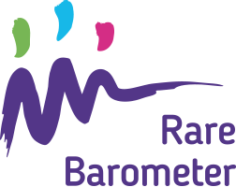
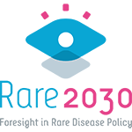

We want to hear from you! Take the new #RareBarometer Survey and have your say on the future of your rare disease #Rare2030: tiny.cc/rare2030survey

How could your care be improved within the next 10 years? Are you willing to use e-consultations more often? Share your views via the new #RareBarometer Survey with #Rare2030: tiny.cc/rare2030survey

Don’t miss the chance to make your voice heard! Have your say on the future of your rare disease, take the new #RareBarometer Survey with #Rare2030. Survey closes on 3rd January: tiny.cc/rare2030survey

