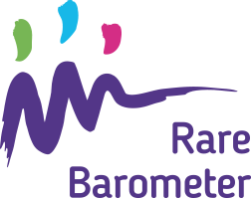
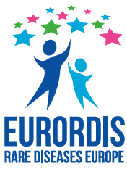
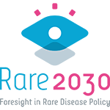

Subject: Make your voice heard: take the new Rare Barometer survey on the future of your rare disease!

The new Rare Barometer survey on the future of your rare disease is now live.
You can access the online survey here
It should take no more than 15 minutes to complete and closes on 3 January 2021. This survey will enable us to gather your opinion on the future of your rare disease and give us the possibility to communicate facts and figures to decision-makers, so that your opinion is taken into account when shaping the future of rare diseases.
Through asking questions on your needs and preferences regarding patients' access to health care, priorities for medical and social research or early diagnosis for children, we will be able to better understand how to shape the future of rare diseases.

This survey is open to people living with a rare disease and their family members from any country in the world. It is translated in 23 languages. All responses are anonymous and will be kept in secure storage only accessible to the Rare Barometer research team.
You can find more information about the survey here.

We need your help to ensure as many people as possible from the rare disease community complete the survey. The more people will take the survey, the stronger our voice will be!

Thank you very much in advance for your participation,
Kind Regards,

